**Tutorial 21: Reaction Timer Game - Start Game**

We are going to create a button that will allow a user to start a new game. When the user clicks the button we want to keep track of whether the user is currently playing the game or not. Clicking the button will also start a timer with a random time between 2 and 7 seconds.

Make sure **Tutorial 20** is complete to be able to move on to this tutorial or clone the [vue3-firebase-course](https://github.com/younggrasshopperza/vue3-firebase-course) repository and go to branch called **Tutorial-20**.

**Step 1:** In the **App.vue** file, create a button with a click event and call the function start. Within the data property, create a variable called isPlaying that has a value of false and create a variable called delay that has a value of null.

Look at the example below (**between line 12 to 16**):

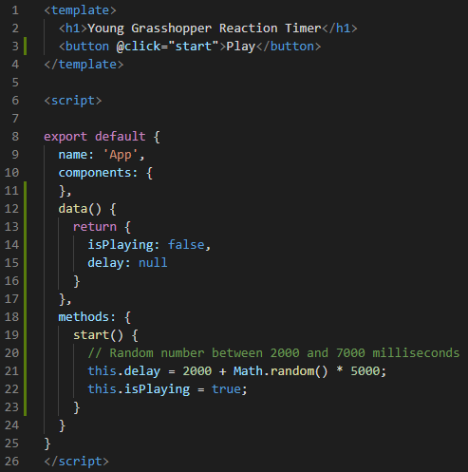

**Output:**

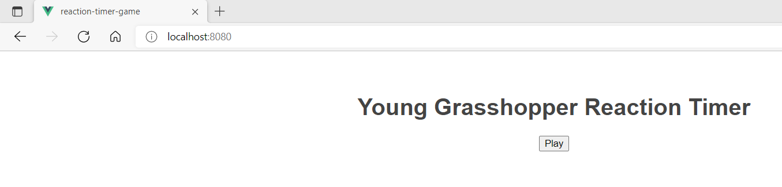

**Step 2:** In the **Block.vue** file, create the template, script and style tags. Inside the template tag create a div tag with a class called block. Inside the div tag write the text “Click Me”. Inside the script tag, create props property with the value delay.

Look at the example below (**between line 1 to 11**):

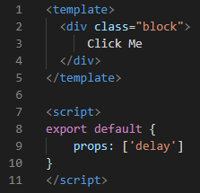

Inside the style tag insert the CSS code below (**copy and paste the code**):

.block {

    width: 400px;

    border-radius: 20px;

    background: #0faf87;

    color: white;

    text-align: center;

    padding: 100px 0;

    margin: 40px auto;

}

**Step 3:** In the **App.vue** file, inside the script tag import the Block component. Inside the components property, call the Block component. In the template tag call the Block component with a conditional block that displays when the user is playing the game. Disable the “Play” button when the user is playing.

Look at the example below (**between line 8 to 12**):

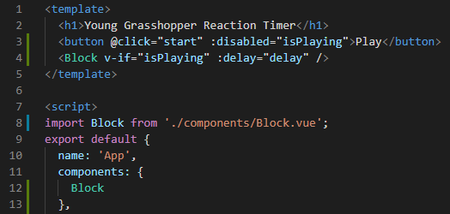

Click Play and view the output.

**Output:**

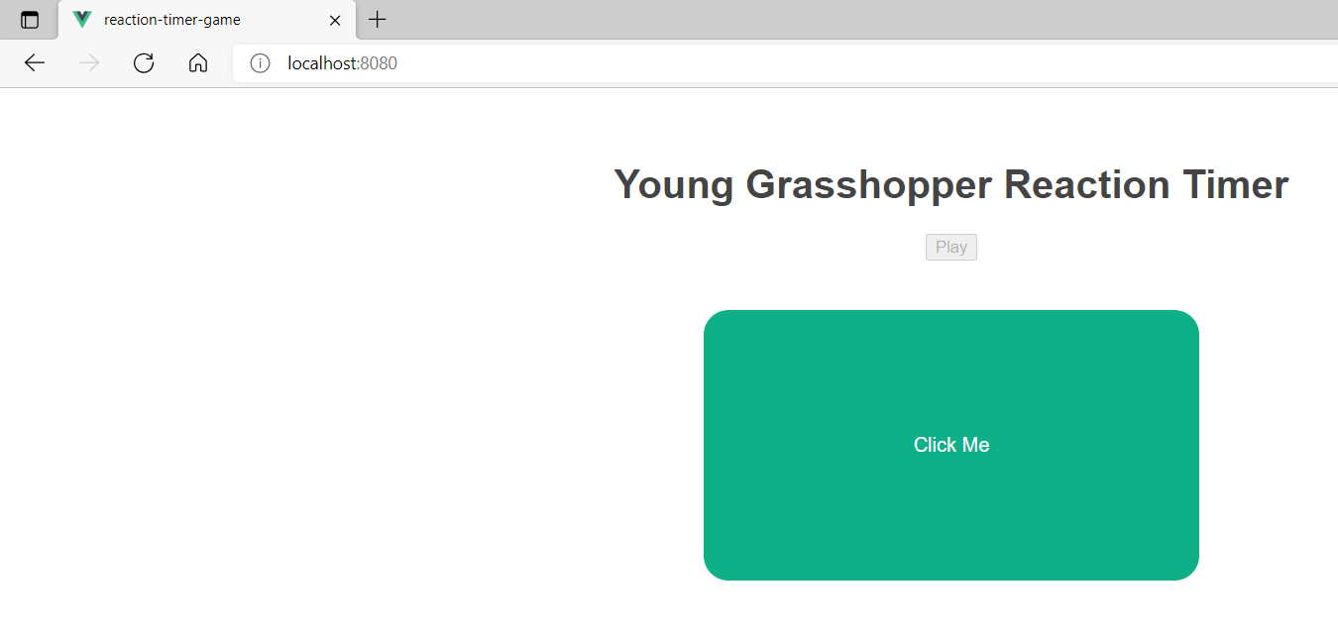

**You can view the code snippets from the** [**vue3-firebase-course**](https://github.com/younggrasshopperza/vue3-firebase-course) **repository under the Tutorial-21 branch**.